Integrated morphological, and genetic characterization of Yemeni coffee (Coffea arabica L.) for drought tolerance, heat resilience, yield potential, and multi-seasons productivity
Ayoub Ahmed Almhab*¹, Ahmed Mohammed Eed²
¹ Ministry of Agriculture, Fishers and Water Resources, Sana’a, Yemen
² Plant Production Department, College of Agriculture and Food Sciences, Ibb University, Ibb, Yemen
*Correspondence: Dr. Ayoub Ahmed Almhab, ayoub.almhab@gmail.com
ORCID: AYOUB ALMHAB (0000-0001-8896-6069) - ORCID
ORCID: Ahmed Mohammed Eed, 0000-0003-0645-6917
Abstract
Yemeni coffee (Coffea arabica L.) represents an important genetic resource associated with the domestication and diversification of Arabica coffee, yet the relationships among its morphological diversity, stress physiology, genetic differentiation, and long-term productivity remain incompletely resolved. This manuscript presents an integrated research framework to characterize Yemeni coffee landraces and identify candidate accessions with drought tolerance, heat resilience, productive potential, and stable multi-season performance. The study will initially characterize 100 mature mother trees across seven coffee-growing governorates (Sana’a, Al Mahwit, Hajjah, Raymah, Ibb, Taiz, and Dhamar), documenting environmental metadata, tree architecture, leaf traits, reproductive characteristics, physiological attributes, and preliminary productivity. Twenty contrasting accessions will then be evaluated under three soil-water regimes in a randomized complete block design with four replicates. Twelve accessions representing contrasting drought responses will subsequently be evaluated under three temperature regimes, and eight accessions will undergo a factorial combined heat–drought experiment. Multi-season productivity will be monitored in 50 field trees for at least three production seasons, while 40–60 selected accessions will undergo molecular characterization using SSR markers or SNP/GBS approaches, depending on available resources. Primary analyses will include mixed-effects models, genotype × treatment and genotype × season interactions, multivariate analyses, molecular clustering, and pre-specified multi-trait indices. The analytical framework will distinguish phenotypic divergence from genetically supported differentiation and will treat climate resilience as a multidimensional phenotype rather than a single trait. The study is designed to provide a transparent basis for identifying and subsequently validating Yemeni coffee genetic resources relevant to conservation, breeding, climate adaptation, and sustainable production.
Keywords: Coffea arabica; landraces; genetic diversity; drought tolerance; heat stress; yield stability.

- Introduction
Coffee (Coffea arabica L.) is a globally important perennial crop whose productivity is increasingly exposed to rising temperatures, irregular rainfall, prolonged drought, and interactions between water and heat stress. These stresses can alter plant water status, stomatal regulation, photosynthesis, vegetative growth, flowering, fruit development, and ultimately yield and quality. Consequently, the identification and conservation of coffee genetic resources with adaptive characteristics are increasingly relevant to climate-resilient production.
Yemen occupies a distinctive position in the history and genetic diversification of cultivated C. arabica. Molecular studies have demonstrated substantial genetic diversity among Yemeni coffee trees and have identified a genetically distinctive “New-Yemen” cluster. Other work based on 148 farms showed that vernacular categories such as Udaini, Tufahi, and Dawairi do not consistently correspond to genetic structure, emphasizing the need to combine farmer knowledge and local nomenclature with objective phenotypic and molecular characterization (Montagnon et al., 2021, 2022).
Yemeni coffee is cultivated across heterogeneous mountainous environments that differ in altitude, temperature, rainfall, soil conditions, water availability, and management practices. Such heterogeneity provides a strong basis for investigating locally maintained diversity. However, genetic diversity alone does not establish drought or heat tolerance; adaptive performance must be evaluated through measurable physiological, agronomic, and, where possible, molecular evidence (Almhab, 2004,2022& 2024), (Almhab. et, al., 2024).
Recent research provides a foundation for this approach. Enabah et al. (2025) evaluated 20 Yemeni coffee landraces for morpho-physiological traits associated with drought resistance under controlled conditions and reported substantial variation among the materials. In Arabica coffee more broadly, genotype-dependent differences in drought responses have been documented for growth, water relations, photosynthesis, pigments, and metabolic traits (Chekol et al., 2024). Heat tolerance also varies within C. arabica, with photosynthetic heat tolerance and thermal safety margins influenced by variety, leaf age, leaf temperature, and water status (Vilas-Boas et al., 2024).
These findings support an integrated approach that moves beyond single-trait screening. Morphological traits can describe phenotypic diversity; physiological traits can reveal mechanisms associated with stress response; yield measurements provide agronomic relevance; multi-season observations distinguish productivity from stability; and molecular markers can provide independent evidence of genetic differentiation. The present study therefore combines field characterization, controlled drought screening, controlled heat screening, combined heat–drought assessment, multi-season productivity monitoring, and molecular characterization.
1.1 Research gap and rationale
Despite increasing interest in Yemeni coffee genetic resources, an integrated framework linking morphology, stress physiology, molecular diversity, and multi-season productivity remains limited. Three gaps are particularly relevant: (i) a phenotypic–physiological gap, because morphological descriptors are not routinely integrated with quantitative drought- and heat-response traits; (ii) a stress-interaction gap, because drought and high temperature are often evaluated separately despite their simultaneous occurrence; and (iii) a genotype–productivity gap, because molecular variation is rarely linked directly to physiological stress responses and multi-season yield stability. The proposed study addresses these gaps through a sequential, traceable design in which the same accession identity is retained across field, physiological, productivity, and molecular datasets.
1.2 Research question and hypotheses
The central research question is: To what extent do Yemeni coffee landraces differ morphologically, physiologically, genetically, and productively, and how are these differences associated with drought response, heat resilience, and stable multi-season productivity?
H1a: Yemeni coffee accessions differ significantly in morphological and reproductive characteristics.
H1b: Accessions differ significantly in physiological responses to increasing water deficit.
H1c: Accessions differ significantly in physiological responses to elevated temperature.
H1d: Accession × stress interactions significantly influence physiological and growth responses.
H1e: Some accessions maintain relatively greater water status, photosynthetic performance, stomatal regulation, and recovery under stress than others.
H1f: Physiological stress-response traits are associated with yield and yield stability.
H1g: Yemeni coffee accessions exhibit measurable molecular genetic differentiation.
H1h: Phenotypic and physiological differentiation is partly associated with molecular genetic variation.
H1i: An integrated multi-trait framework can identify candidate accessions combining stress resilience with productive performance.
1.3 Objectives
The overall objective is to characterize Yemeni coffee landraces morphologically, physiologically, genetically, and productively and to evaluate drought tolerance, heat resilience, yield potential, and multi-season productivity stability. Specific objectives are to:
- document representative mother trees across contrasting coffee-growing regions;
- quantify morphological, physiological, reproductive, and preliminary productivity variation;
- evaluate drought responses under controlled water regimes;
- evaluate heat responses under controlled temperature regimes;
- quantify responses to combined heat and drought;
- assess flowering, fruit set, fruit development, cherry production, green coffee yield, and yield stability across at least three production seasons;
- characterize genetic diversity using SSR or SNP/GBS markers;
- determine relationships among morphological, physiological, environmental, productivity, and molecular variables;
- and identify candidate accessions for subsequent multi-location validation, conservation, breeding, and climate-adaptation research.

1.4 Conceptual framework
The study treats climate resilience as a multidimensional phenotype. The proposed causal framework is:
Genetic diversity → Morphological traits → Physiological responses → Stress tolerance → Yield performance → Multi-season stability
Environmental context (altitude + temperature + rainfall + soil + water availability + management) modifies genotype performance.
Morphologically unusual trees will initially be described as phenotypically divergent rather than genetically distinct. Terms such as genotype, allele, or mutation will be used only when supported by molecular evidence.
1.5 Synthesis of Previous Studies and Identification of Research Gaps
Previous research relevant to this study can be grouped into three main areas. First, studies of Yemeni coffee have documented local diversity and genetic structure, providing an important foundation for evaluating accessions according to their actual characteristics rather than relying exclusively on vernacular names (Montagnon et al., 2022). Second, morphological studies in other coffee-growing regions have demonstrated that quantitative traits and multivariate analytical methods are useful for classifying accessions and identifying potential candidates for selection (Ndikumana et al., 2021). Third, studies of drought responses in Arabica coffee have shown that physiological and metabolic differences among genotypes can help explain variation in their responses to water stress (Chekol et al., 2024).
Nevertheless, these studies do not collectively provide sufficient evidence to identify Yemeni coffee accessions that combine drought tolerance, heat resilience, favorable yield potential, and stable productivity across successive seasons. The research gap addressed by the present study is therefore the integration of morphological, physiological, and genetic characterization with experimental stress evaluation and multi-season yield assessment within a unified analytical framework. This integrated approach would move beyond documenting diversity toward evaluating its adaptive and agricultural value. It would also help identify promising accessions for further testing, while recognizing that their performance must be validated under field conditions across multiple locations and seasons before they can be considered superior.
2. Materials and methods
2.1 Study design and overall research framework
The study will use a sequential, multi-stage framework combining field germplasm characterization, controlled drought screening, controlled heat-stress evaluation, combined heat–drought assessment, multi-season productivity monitoring, and molecular characterization. The staged design progressively reduces the number of accessions while increasing experimental intensity and measurement resolution Figure1.
Stage I: field collection and characterization of approximately 100 representative mother trees.
Stage II: morphological and physiological characterization and selection of 20 contrasting accessions for controlled drought screening.
Stage III: selection of 12 accessions representing contrasting drought responses for heat-stress evaluation, followed by selection of eight accessions for combined heat–drought assessment.
Stage IV: multi-season monitoring of productivity and yield stability in 50 field trees.
Stage V: molecular characterization of approximately 40–60 selected accessions and integration of molecular, phenotypic, physiological, and productivity datasets.
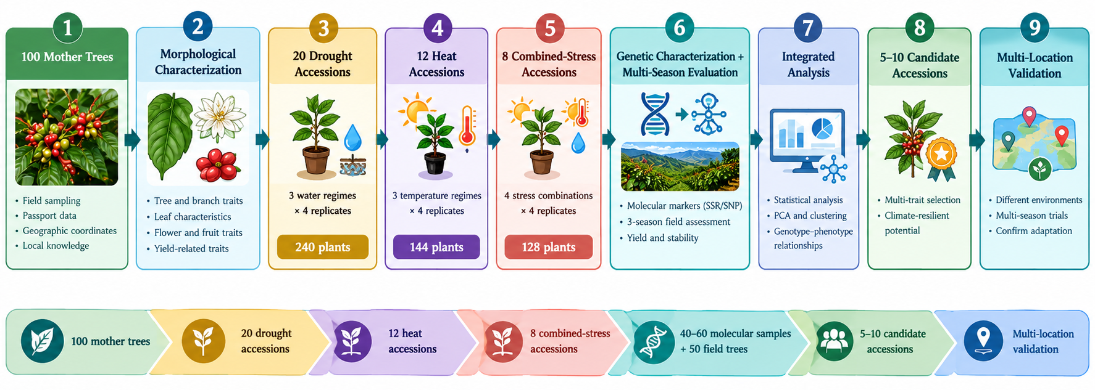
Figure 1. Overall Research Workflow

2.2 Study area and sampling regions
Yemen is located in the south western part of Asia and in the south of Arabian Peninsula. The coffee growing in the western slopes in Yemen between longitudes 13 and 15 north and 43 to 45 east figure 1(Almhab, 2022). Coffee is grown in 16 Governorate and more production is limited to 12 Governorate, figure 1(Almhab, 2004&2022). The field component will cover seven Yemeni coffee-growing governorates representing contrasting agroecological conditions: Sana’a, Al Mahwit, Hajjah, Raymah, Ibb, Taiz, and Dhamar. The sampling framework is intended to capture variation in altitude, temperature, rainfall, soil conditions, water availability, and traditional management.
Table 1. Proposed distribution of Yemeni coffee mother trees across sampling regions
Governorate | Proposed Number of Mother Trees | Sampling Purpose
Sana’a | 15 | Representation of local coffee diversity across elevation and production environments
Al Mahwit | 15 | Representation of highland coffee environments and local landraces
Hajjah | 15 | Representation of diverse agroecological and traditional coffee-growing systems
Raymah | 15 | Representation of high-elevation coffee-growing environments
Ibb | 15 | Representation of relatively humid and productive coffee environments
Taiz | 15 | Representation of diverse elevation, temperature, and water-availability conditions
Dhamar | 10 | Representation of highland and comparatively cooler production environments
Total | 100 | Initial field characterization and mother-tree selection

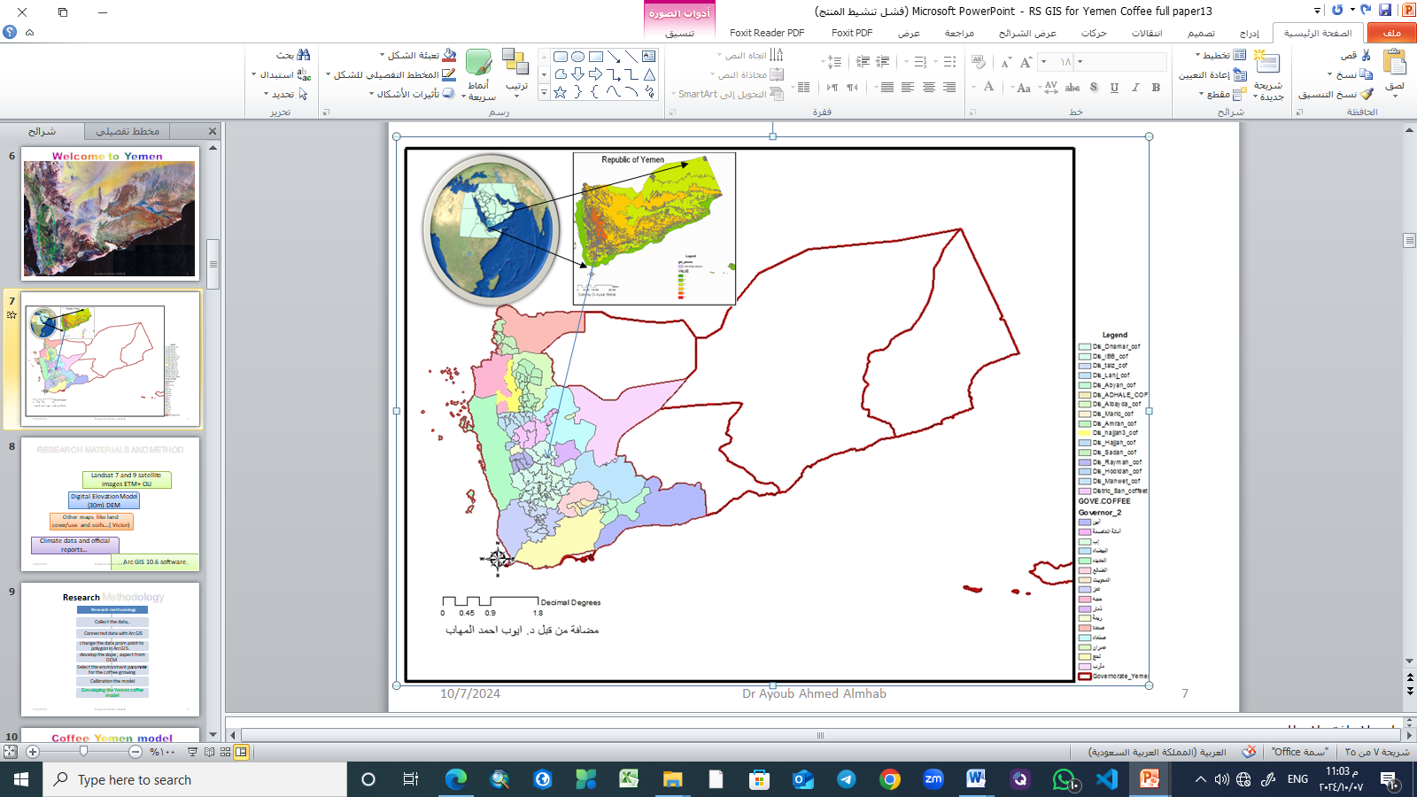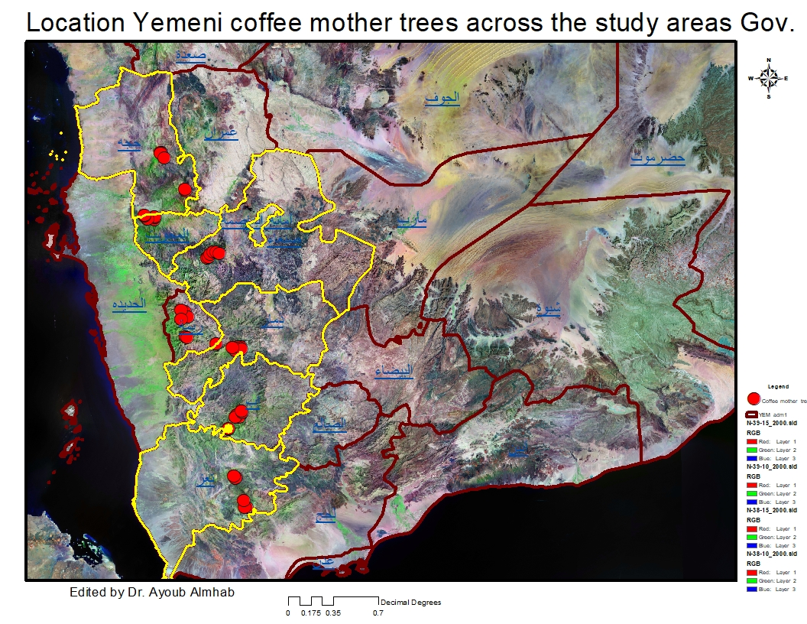
Figure 2. The Study area and Geographic distribution of sampled Yemeni coffee mother trees across sampling regions
2.3 Selection and identification of mother trees
Mature and apparently healthy trees will be identified with farmers and local agricultural specialists. Selection will prioritize biological and geographic diversity rather than simply selecting the highest-yielding trees. Criteria will include representation of locally recognized types, geographic separation, altitude and microenvironment, tree architecture, farmer knowledge, productivity and fruiting behavior, and absence of severe disease or irreversible damage.
Each tree will receive a permanent identifier (YEM-CF-001 to YEM-CF-100) retained across field measurements, physiological experiments, yield records, and molecular samples. Passport information will include governorate, district, locality, coordinates, altitude, local name, estimated age, irrigation status, water source, soil type, shade, tree health, management practices, flowering history, fruiting history, and previous yield information where available.

2.4 Morphological and reproductive characterization
Morphological characterization will be conducted on the 100 mother trees. Measurements will be taken from representative branches and mature, fully expanded leaves using standardized procedures and calibrated instruments. Multiple canopy positions will be sampled where appropriate to reduce positional bias.
Table 2. Morphological and reproductive traits to be recorded
Trait Category | Trait | Unit / Scale | Measurement Method or Timing
Tree architecture | Tree height | m | Measured from soil surface to the highest vegetative point
Tree architecture | Stem diameter | mm | Measured at a standardized stem height
Tree architecture | Crown diameter | m | Mean of two perpendicular crown measurements
Branching | Number of primary branches | No. tree⁻¹ | Direct count
Branching | Productive branch length | cm | Mean length of representative productive branches
Branching | Internode length | cm | Mean distance between successive nodes
Leaf morphology | Leaf length | cm | Mature, fully expanded leaves
Leaf morphology | Leaf width | cm | Maximum width of the same leaves
Leaf morphology | Leaf area | cm² | Direct measurement or calibrated leaf-area meter
Leaf morphology | Length-to-width ratio | — | Leaf length / leaf width
Leaf morphology | Leaf thickness | mm | Measured using a digital thickness gauge
Leaf physiology proxy | SPAD chlorophyll index | SPAD units | Mean of standardized mature leaves
Reproductive traits | Number of inflorescences | No. branch⁻¹ | Count during flowering
Reproductive traits | Number of flowers | No. inflorescence⁻¹ | Count on representative inflorescences
Reproductive traits | Fruit set | % | Fruits formed relative to initial flowers
Fruit traits | Fruits per node | No. node⁻¹ | Count on representative productive branches
Fruit traits | Fruit length | mm | Mature coffee cherries
Fruit traits | Fruit diameter | mm | Maximum transverse diameter
Fruit traits | Fresh fruit weight | g fruit⁻¹ | Individual or representative cherry sample
Fruit traits | 100-fruit weight | g | Standardized sample of 100 mature cherries
Productivity | Green coffee yield per tree | kg tree⁻¹ | Post-harvest processing and weighing
Productivity | Green coffee conversion | % | Green coffee weight relative to harvested fresh cherry weight

2.5 Physiological characterization
Physiological measurements will focus on plant water status, gas exchange, stomatal regulation, photochemical performance, thermal response, membrane stability, growth retention, and recovery. Principal variables will include relative water content (RWC), stomatal conductance (gₛ), net photosynthetic rate (A), transpiration (E), intrinsic water-use efficiency (iWUE), maximum quantum yield of photosystem II (Fv/Fm), leaf temperature, SPAD chlorophyll index, electrolyte leakage, wilting score, growth and biomass retention, and recovery after rewatering.
Intrinsic water-use efficiency will be calculated as iWUE = A/gₛ. Relative water content will be calculated as RWC (%) = [(FW − DW)/(TW − DW)] × 100, where FW is fresh mass, TW is fully turgid mass, and DW is dry mass.
Table 3. Physiological indicators and their primary interpretation
Trait / Indicator | Abbreviation | Unit | Primary Interpretation
Relative water content | RWC | % | Plant water status and tissue hydration
Stomatal conductance | Gs | mol H₂O m⁻² s⁻¹ | Stomatal regulation under water and heat stress
Net photosynthetic rate | A | μmol CO₂ m⁻² s⁻¹ | Photosynthetic performance
Transpiration rate | E | mmol H₂O m⁻² s⁻¹ | Water loss through transpiration
Intrinsic water-use efficiency | iWUE | μmol CO₂ mol⁻¹ H₂O | A / gs; photosynthetic carbon gain relative to stomatal water loss
Maximum quantum efficiency of PSII | Fv/Fm | ratio | Photochemical efficiency and photosynthetic stress
Leaf temperature | Tleaf | °C | Thermal status and heat-load response
Electrolyte leakage | EL | % | Membrane stability and cellular injury
Wilting score | WS | ordinal scale | Visible drought-response severity
Biomass retention | BR | % | Ability to maintain biomass under stress
Relative growth rate | RGR | g g⁻¹ day⁻¹ | Growth maintenance under stress
Recovery after rewatering | REC | % or score | Post-stress recovery capacity
Drought tolerance index | DTI | standardized index | Integrated drought-response performance
Heat tolerance index | HTI | standardized index | Integrated heat-response performance

2.6 Preliminary selection of accessions
Twenty accessions will be selected after the initial field characterization. Selection will not be based on a single trait but will represent contrasting combinations of tree architecture, leaf characteristics, preliminary physiological performance, environmental origin, altitude, productivity, and farmer-recognized diversity. Final claims of drought or heat tolerance will be reserved for the outcomes of the controlled experiments and planned analyses Figure 3.
2.7 Controlled drought experiment
2.7.1 Experimental design
The drought experiment will use a randomized complete block design with 20 accessions × 3 water regimes × 4 replicates = 240 experimental plants. Each experimental unit will contain one plant.

Table 4. Target soil-water regimes for the drought experiment
Treatment | Target Soil Water Level | Experimental Interpretation | Duration
W1 – Well-watered control | 70–80% field capacity | Non-stress/reference condition | 35 days
W2 – Moderate drought | 45–50% field capacity | Moderate water deficit | 35 days
W3 – Severe drought | 25–30% field capacity | Severe water deficit | 35 days
Recovery | Rewatered to control level | Assessment of post-drought recovery | 7 days

2.7.2 Growing containers, substrate, and field capacity
Plants will be grown in 8–10 L pots with adequate drainage using a homogenized soil:washed sand:organic matter mixture of approximately 2:1:1. Baseline pH, electrical conductivity, organic matter, total nitrogen, available phosphorus, and exchangeable potassium will be characterized. Nutrient management will be uniform across treatments.
Field capacity will be determined gravimetrically. Pots containing dry substrate will be weighed, saturated, allowed to drain, and reweighed after drainage stabilizes. Target treatment masses will be calculated from the field-capacity water difference using Wₜ = W₀ + f(WFC − W₀), where Wₜ is target pot mass, W₀ is baseline mass, WFC is mass at field capacity, and f is the target fraction of field capacity. Irrigation will therefore be based on pot mass and measured soil moisture rather than a fixed water volume.
2.7.3 Experimental timeline and measurements
Plants will undergo 14 days of acclimation under uniform irrigation, followed by gradual establishment of drought treatments. Baseline measurements will be taken before stress imposition; assessments will occur at Days 7, 14, 21, 28, and 35, followed by rewatering and recovery assessment during Days 38–42. Soil moisture, growth, SPAD, wilting, RWC, gas exchange, leaf temperature, iWUE, Fv/Fm, electrolyte leakage, and recovery variables will be recorded according to the pre-specified schedule.

2.8 Heat-stress experiment
Following drought screening, 12 accessions representing contrasting drought-response classes will be selected for heat evaluation. The experiment will use 12 accessions × 3 temperature treatments × 4 replicates = 144 plants.

Table 5. Target temperature regimes for the heat experiment
Treatment | Target Day Temperature | Experimental Interpretation | Duration
H1 – Control | 26 ± 2 °C | Non-heat-stress reference | 7 days
H2 – Moderate heat | 34 ± 2 °C | Moderate heat stress | 7 days
H3 – High heat | 38 ± 2 °C | High heat stress | 7 days
Recovery | 26 ± 2 °C | Assessment of post-heat recovery | 7 days
A 7–10-day pilot experiment will be used to verify that the selected temperatures produce distinguishable but non-destructive responses. The main treatment will last approximately seven days, with measurements before treatment, during stress, and after recovery. Variables will include leaf temperature, RWC, SPAD, photosynthetic rate, stomatal conductance, transpiration, Fv/Fm, electrolyte leakage, visible injury, wilting, and recovery.
Where instrumentation permits, temperature-response measurements of PSII performance will also be considered to estimate photosynthetic heat tolerance more directly. This is consistent with evidence that heat tolerance in C. arabica is related to leaf temperature and water status (Vilas-Boas et al., 2024).
2.9 Combined heat–drought experiment
Eight accessions selected from the preceding experiments will be evaluated in a factorial design comprising four treatments: well-watered/normal temperature, drought/normal temperature, well-watered/high temperature, and drought/high temperature. The design will include 8 accessions × 4 stress treatments × 4 replicates = 128 plants.

Table 6. Combined heat–drought treatment structure
Treatment | Water status | Temperature
C | Well watered | Normal
D | Drought | Normal
H | Well watered | High temperature
DH | Drought | High temperature
The factorial design will distinguish drought-specific effects, heat-specific effects, additive effects, and heat × drought interactions. Water stress will be established before the heat treatment, and soil moisture will be monitored throughout the heat exposure so that temperature does not inadvertently alter the intended drought level.
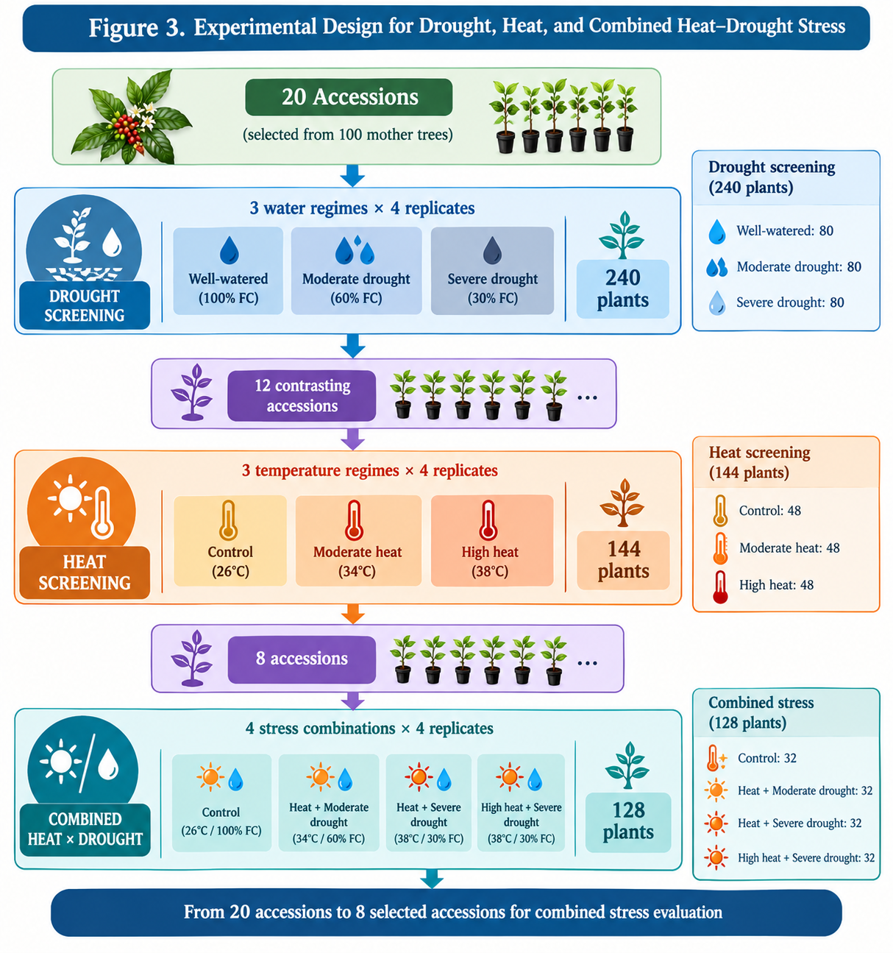
Figure 3. Experiment design for drought, heat and combine drought heat stress

2.10 Multi-season productivity assessment
Fifty of the original 100 field trees will be followed for at least three consecutive production seasons. Phenological observations will include flowering initiation and intensity, fruit-set date, fruit development duration, cherry production, green coffee yield, and yield components. Year-to-year stability will be quantified using appropriate variability and stability statistics rather than single-season yield alone.
2.11 Molecular genetic characterization
Approximately 40–60 accessions will be selected to maximize representation of morphological divergence, contrasting drought and heat responses, yield performance, multi-season stability, geographic origin, altitude, and vernacular names. Young healthy leaves will be collected and linked to the original YEM-CF accession code.
Genomic DNA will be extracted using a validated plant-DNA protocol and evaluated for concentration, A260/A280 ratio, and integrity where appropriate. Two analytical platforms are pre-specified: SSR markers, which offer continuity with previous Yemeni coffee work, or SNP-based genotyping/GBS where sufficient resources are available. Whole-genome sequencing is not required for the first phase.
Molecular analyses will estimate allele frequencies, genetic diversity, pairwise genetic distance, genetic similarity, population structure, genetic clustering, and principal coordinate analysis (PCoA). Molecular groups will be compared with morphological, physiological, geographic, and productivity patterns. Figure 4 summarize Coffee research workflow.
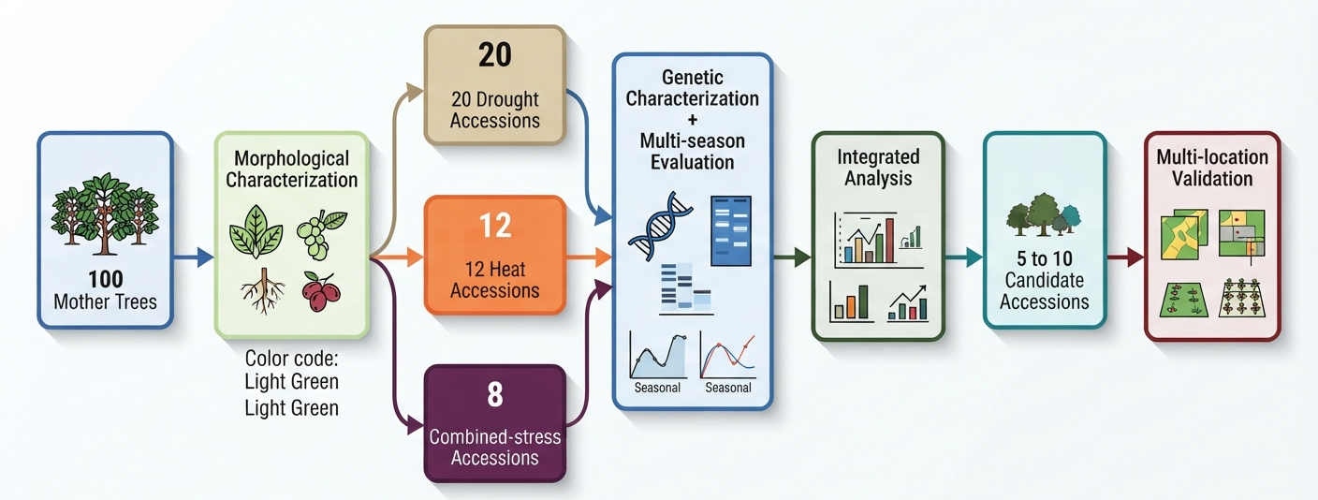
Figure 4. Coffee research workflow; stress tolerance screening and genetic improvement

2.12 Drought, heat, and integrated selection indices
Drought response will be summarized using a Drought Tolerance Index (DTI) based on standardized retention of RWC, SPAD, photosynthetic rate, stomatal conductance, growth or biomass, wilting response, and recovery after rewatering. Heat response will be summarized using a Heat Tolerance Index (HTI) incorporating Fv/Fm retention, photosynthetic rate, RWC, leaf-temperature response, electrolyte leakage, visible injury, and recovery.
The integrated selection framework will combine drought tolerance, heat resilience, yield potential, multi-season stability, morphology, physiology, and genetic distinctiveness. The source protocol proposes preliminary weights of 25%, 20%, 20%, 20%, 5%, 5%, and 5%, respectively. These preliminary weights are methodological starting points rather than empirical results. Final weighting will be justified before the final integrated analysis, and any change will be documented together with a sensitivity analysis using an alternative weighting scheme. Figure 5 summarize the Experiment stress- Response Timeline.
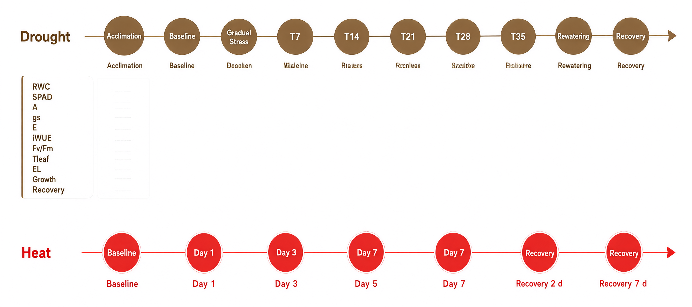
Figure 4. Experiment stress- Response Timeline
2.13 Statistical analysis
Analyses will be conducted in R, SAS, GenStat, or equivalent validated software. The primary model for controlled drought and heat experiments will include accession, treatment, accession × treatment interaction, block, and residual error. Repeated observations over time will be analyzed using mixed-effects or repeated-measures models rather than treating repeated measurements as independent replicates.
For multi-season productivity, season will be modeled explicitly and accession/tree effects will be evaluated with appropriate random effects where required. Accession × season interactions will be used to assess stability. Estimated marginal means and multiplicity-adjusted pairwise comparisons will be reported where post hoc comparisons are warranted.
Multivariate analyses will include principal component analysis, hierarchical clustering, and PCoA as appropriate to the measurement scale. Relationships among morphological, physiological, productivity, environmental, and molecular variables will be assessed using correlation and multivariate approaches. Correlation will not be interpreted as evidence of causation.
Where appropriate, effect sizes and confidence intervals will accompany p-values. Assumptions of the statistical models will be assessed using residual diagnostics, normality checks, and variance-homogeneity diagnostics. Where assumptions are materially violated, transformations or robust/mixed-model alternatives will be applied according to the pre-specified analysis plan.
The principal confirmatory inference will focus on accession, treatment, and accession × treatment effects in the controlled experiments; accession × season effects for productivity stability; and concordance or discordance between molecular clustering and phenotypic/physiological differentiation. Exploratory analyses will be clearly labeled.
2.14 Final field validation
Approximately 5–10 candidate accessions emerging from the integrated analysis will be prioritized for subsequent independent validation at at least two contrasting coffee-growing locations. This validation is outside the confirmatory scope of the present Stage 1 protocol unless data are collected under the planned design; its purpose is to test whether controlled-environment responses are maintained under representative field conditions.
2.15 Quality control and experimental reliability
Quality control will include calibrated instruments, standardized measurement times where feasible, consistent developmental leaf positions, traceable accession codes, uniform nutrient management, monitored soil moisture, and documented deviations from target environmental conditions. Raw measurements, exclusions, missing observations, and methodological deviations will be retained in a structured database.
2.16 Ethical and germplasm documentation
Because the study involves locally maintained genetic resources, collection procedures will document farmer consent where applicable, collection location, traditional knowledge associated with the sampled tree, local name, planting-material source where known, collection date, geographic coordinates, and subsequent use of germplasm. Traditional knowledge, vernacular nomenclature, phenotype, and genetically confirmed identity will be treated as distinct information categories.
2.17 Data management and transparency
A structured database will link tree identity, environmental metadata, treatment, measurement date, laboratory results, and molecular information. The analysis plan, code where feasible, and de-identified derived datasets should be archived in a stable repository before or at the time of manuscript submission, subject to germplasm and data-sharing constraints.
2.18 Summary of the experimental framework
The complete staged workflow is: 100 field mother trees → morphological and physiological characterization → 20 accessions for drought screening → 12 accessions for heat screening → 8 accessions for combined heat × drought screening → 50 trees for multi-season productivity → 40–60 accessions for molecular characterization → integrated statistical analysis → approximately 5–10 candidate accessions → independent multi-location validation.
Table 7. Integrated experimental workflow and decision points
Phase | Experimental Activity | Sample Size | Main Measurements / Outputs | Decision Point
Phase I | Field reconnaissance and mother-tree sampling | 100 trees | GPS, altitude, environment, local name, tree characteristics, health, preliminary yield | Establish representative Yemeni coffee collection
Phase II | Morphological and reproductive characterization | 100 trees | Tree, branch, leaf, flower, fruit, and preliminary yield traits | Identify phenotypically divergent accessions
Phase III | Controlled drought screening | 20 accessions × 3 treatments × 4 replicates = 240 plants | RWC, gs, A, E, iWUE, SPAD, Fv/Fm, Tleaf, growth, wilting, recovery | Select contrasting drought-response accessions
Phase IV | Controlled heat screening | 12 accessions × 3 treatments × 4 replicates = 144 plants | RWC, gas exchange, Fv/Fm, Tleaf, electrolyte leakage, injury, recovery | Select contrasting heat-response accessions
Phase V | Combined heat × drought screening | 8 accessions × 4 treatments × 4 replicates = 128 plants | RWC, A, gs, Fv/Fm, Tleaf, growth, injury, recovery | Identify accessions with combined-stress resilience
Phase VI | Multi-season productivity assessment | 50 field trees | Flowering, fruit set, fruit development, cherry yield, green coffee yield, CV, stability | Assess yield potential and seasonal stability
Phase VII | Molecular genetic characterization | 40–60 accessions | DNA quality, SSR/SNP genotype, genetic distance, population structure | Quantify genetic diversity and genotype–phenotype relationships
Phase VIII | Integrated statistical analysis | Full dataset | ANOVA/mixed models, G×T, G×S, PCA, clustering, PCoA, stability analysis | Integrate phenotype, physiology, productivity, and genetics
Phase IX | Multi-trait selection | 5–10 candidate accessions | DTI, HTI, yield, stability, morphology, physiology, genetic distinctiveness | Identify candidate climate-resilient accessions
Phase X | Multi-location validation | 5–10 accessions at ≥2 sites | Yield, physiology, flowering, fruit set, fruit weight, green coffee, stability | Confirm field performance and adaptation

3. Expected Results
3.1. Morphological and Reproductive Variation
The study is expected to characterize the extent of morphological and reproductive variation among Yemeni coffee (Coffea arabica L.) accessions, particularly in tree architecture, branching patterns, leaf characteristics, reproductive development, fruit traits, and yield components. Principal component analysis (PCA) and hierarchical clustering will be used to identify patterns of phenotypic variation and distinguish accessions with contrasting combinations of agronomic traits. These analyses may help identify accessions with potentially desirable growth and reproductive characteristics. However, phenotypic differences will not be interpreted as evidence of genetic differentiation unless supported by molecular data.

3.2. Physiological Responses to Drought, Heat, and Combined Stress
The controlled experiments are expected to reveal differences among accessions in their responses to drought, elevated temperature, and the simultaneous occurrence of both stresses. Relevant indicators will include relative water content (RWC), stomatal conductance, net photosynthetic rate, chlorophyll status, maximum quantum efficiency of photosystem II (Fv/Fm), leaf temperature, electrolyte leakage, growth retention, visible injury, and post-stress recovery.
Accessions that maintain comparatively favorable physiological function and recover more effectively under stress will be considered promising candidates for further evaluation. The combined-stress experiment will additionally determine whether responses to simultaneous drought and heat differ from those observed under either stress individually. Genotype-by-treatment interactions will be examined to establish whether accessions differ significantly in their responses to stress intensity and combinations. These outcomes will provide a comparative basis for identifying candidate sources of drought tolerance, heat resilience, and combined-stress adaptation.
3.3. Genetic Diversity and Genotype–Phenotype Relationships
Molecular characterization is expected to provide estimates of genetic diversity and differentiation among the sampled accessions, with the specific outputs depending on the marker system employed. Analyses may include genetic distances, clustering patterns, population structure, and relationships between genetic variation and geographic origin.
The integration of molecular, morphological, and physiological data will help determine the extent to which phenotypic differences correspond to molecular differentiation. Particular attention will be given to the relationship between vernacular names and genetic profiles, without assuming that accessions sharing a local name are genetically identical or that differently named accessions are necessarily distinct. Any associations between molecular markers and stress-response or productivity traits will be interpreted according to the statistical power and limitations of the dataset; marker variation alone will not be considered proof of specific genes controlling drought tolerance, heat resilience, or yield.
3.4. Multi-Season Productivity and Yield Stability
The assessment of selected field trees across at least three production seasons is expected to quantify variation in flowering, fruit set, fruit development, harvested cherry production, green coffee yield, and year-to-year productivity. Mean yield will be evaluated separately from yield stability to distinguish accessions that produce well in a single favorable season from those that maintain comparatively consistent production over time.
Repeated-measures and mixed-effects analyses, where appropriate, will be used to assess accession, season, and accession-by-season effects while accounting for repeated observations and relevant environmental or management differences. The results are expected to support the identification of accessions with favorable yield potential and those exhibiting comparatively stable performance across seasons. Potential alternate-bearing patterns will also be considered when interpreting productivity differences.
3.5. Integrated Identification of Candidate Climate-Resilient Accessions
The combined analysis of morphological, physiological, molecular, and multi-season productivity data is expected to identify a limited group of accessions meriting further evaluation. Selection will consider multiple criteria, including performance under drought and heat stress, maintenance of physiological function, recovery capacity, measured yield, yield stability, and the contribution of each accession to the representation of genetic diversity.
A multi-trait selection framework will be developed to compare accessions consistently and transparently. PCA, clustering, and appropriate statistical models will be used to identify meaningful patterns of variation, while selection criteria and weighting procedures will be defined and justified before final ranking. Approximately 5–10 accessions may be prioritized for subsequent validation, subject to the quality and consistency of the experimental evidence. Their designation as candidate climate-resilient accessions will remain provisional until their performance is confirmed in replicated trials across contrasting coffee-growing environments and additional production seasons.
3.6. Overall Research Contribution
The principal anticipated contribution is an integrated and reproducible framework for characterizing Yemeni coffee genetic resources and identifying accessions with promising combinations of stress response, productivity, and yield stability. By linking field observations with controlled stress experiments, molecular characterization, and multi-season yield assessment, the study is expected to strengthen the evidence base for germplasm conservation, future breeding research, and climate-adaptation planning in Yemen.
The study will not presume the superiority of any particular accession in advance. Instead, it will establish an evidence-based procedure for evaluating candidate accessions and prioritizing those that warrant further testing. The resulting information may also provide a foundation for a more systematically documented Yemeni coffee germplasm resource, supporting the conservation of genetic diversity while maintaining the distinction between preliminary candidate identification and validated agricultural performance.

4. Conclusions
This study is expected to provide an integrated assessment of morphological, physiological, and genetic diversity among Yemeni coffee (Coffea arabica L.) accessions, with particular emphasis on drought tolerance, heat resilience, yield potential, and multi-season productivity. By combining controlled stress experiments, molecular characterization, and field-based yield assessment, the research will establish a systematic basis for identifying promising accessions and evaluating their potential for climate adaptation.
The anticipated findings may support the conservation and utilization of Yemen’s coffee genetic resources and guide future breeding and validation programs. However, the superiority and climate resilience of candidate accessions must be confirmed through replicated, multi-location trials across additional production seasons.

5. Declarations
5.1 Data availability statement
The present manuscript describes the planned experimental and analytical framework and therefore does not yet report empirical results. The final study dataset and analysis code will be deposited in an appropriate open repository where permitted by institutional, germplasm, and participant/data-governance requirements.
5.2 Ethics and germplasm statement
The study will follow applicable institutional and national requirements for collection and use of plant genetic resources and will document farmer consent and germplasm provenance where applicable.
5.3. Funding
This research received no internal or external funding.
5.4. Conflict of Interest
The authors declare no conflict of interest.
5.5 Artificial Intelligence Disclosure
During the preparation of this scientific paper, the author used the free version of ChatGPT (version 3.5) for language review and to improve the figures. The AI-generated output was reviewed, edited, and verified by the authors, who bear full responsibility for the content of this publication.
References
Alemu, Abraham, and Ebisa Dufera. "Climate smart coffee (Coffea arabica) production." American Journal of Data Mining and Knowledge Discovery 2.2 (2017): 62-68.
Al-Hakimi, A., & Enabah, S. (2025). Effect of drought on root and vegetative system growth in coffee seedlings (Coffea arabica L.) under controlled conditions. The International Journal for Scientific Research, 4(7). https://doi.org/10.59992/IJSR.2025.v4n7p3
Almhab, A. A. (2004). “Water requirements for coffee crops in different regions of the Republic of Yemen. The first national workshop on coffee in Yemen. - Sana’a: Ministry of Agriculture and Irrigation - College of Agriculture - Sana’a University - Yemen.
Almhab, Ayoub Ahmed, 2022, Application of remote sensing techniques and geographic information systems in studying the current status of Arabic coffee and a proposed vision to improve its quantity and quality in Yemen, Saada University Journal, Issue 2, July - September 2022, pp. 1-27, Saada University, Saada, Yemen.
Almhab A. A., 2024, Coffee Value Chain Analysis – Yemen, Implemented by the Small and Micro Enterprises Promotion Service (SMEPS),with the United Nations Development Programme (UNDP) in Yemen and funded by the European Union (EU) , Sanaa Yemen .
Almhab, Ayoub Ahmed, Ali Zeyad and Hadi Almohab, 2024, Enhancing Coffee Value Chains in Yemen Through Geo AI and Earth Observation for Sustainable Development, INTERNATIONAL CONFERENCE OF INNOVATIVE BIOFRONTIERS STUDENTS (ICIBS), Malang, Indonesia, 28 October 2024, Malang, Indonesia.
Al-Najjar, A., Dijkxhoorn, Y., Zubiry, R., & Ruben, R. (2023). Understanding coffee farming practices and prospects in Yemen: Case study from Bani Matar (Wageningen Economic Research Report No. 2023-044). Wageningen Economic Research. https://doi.org/10.18174/589422
Andini, R., Zaelani, A., Sulaiman, M. I., Sembiring, E. R., Jaya, R., Gusain, M., Bhanot, D., Morghade, R. S., Gaafar, A.-R. Z., Azis, A., & Widayat, H. P. (2025). Genetic diversity of cultivated Gayo Arabica coffee (Coffea arabica L.) based on morphological and microsatellite markers. BMC Plant Biology, 25, Article 990. https://doi.org/10.1186/s12870-025-06768-4
Chekol, H., Warkineh, B., Shimber, T., Mierek-Adamska, A., Dąbrowska, G. B., & Degu, A. (2024). Drought stress responses in Arabica coffee genotypes: Physiological and metabolic insights. Plants, 13(6), 828. https://doi.org/10.3390/plants13060828
DaMatta, F. M., & Ramalho, J. D. C. (2006). Impacts of drought and temperature stress on coffee physiology and production: A review. Brazilian Journal of Plant Physiology, 18(1), 55–81. https://doi.org/10.1590/S1677-04202006000100006
Enabah, S. M. A., Munibari, M., & Al-Hakimi, A. (2025). Evaluation of genetic variation in Yemeni coffee landraces (Coffea arabica L.) for some morpho-physiological traits related to drought resistance. Sana'a University Journal of Applied Sciences and Technology, 3(6), 1241–1258. https://doi.org/10.59628/jast.v3i6.2147
INATrace. (n.d.). INATrace platform for coffee producers. Retrieved from https://www.inatrace.com
Läderach, P., Ramirez–Villegas, J., Navarro-Racines, C., Zelaya, C., Martinez–Valle, A., & Jarvis, A. (2017). Climate change adaptation of coffee production in space and time. Climatic change, 141(1), 47-62.
Montagnon, C., Mahyoub, A., Solano, W., & Sheibani, F. (2021). Unveiling a unique genetic diversity of cultivated Coffea arabica L. in its main domestication center: Yemen. Genetic Resources and Crop Evolution, 68, 2411–2422. https://doi.org/10.1007/s10722-021-01139-y
Montagnon, C., Rossi, V., Guercio, C., & Sheibani, F. (2022). Vernacular names and genetics of cultivated Coffea arabica in Yemen. Agronomy, 12(8), 1970. https://doi.org/10.3390/agronomy12081970
Ndikumana, J., Mwangi, G., Wainaina, C., & Kufa, T. (2021). Agro-morphological characterization of Arabica coffee cultivars in Burundi. International Journal of Plant Breeding and Genetics, 15(1), 14–23. https://doi.org/10.3923/ijpbg.2021.14.23
Santos-Rivera, M., Montagnon, C. & Sheibani, F., (2024), Identifying the origin of Yemeni green coffee beans using near infrared spectroscopy: a promising tool for traceability and sustainability. Sci Rep 14, 13342. https://doi.org/10.1038/s41598-024-64074-9
Tezara, W., Loyaga, D. W., Reynel Chila, V. H., & Herrera, A. (2024). Photosynthetic limitations and growth traits of four Arabica coffee (Coffea arabica L.) genotypes under water deficit. Agronomy, 14(8), Article 1713. https://doi.org/10.3390/agronomy14081713
UNDP. (2022). Value Chain Analysis: Qat and Coffee in Yemen. Retrieved from https://www.undp.org/sites/g/files/zskgke326/files/2022-08/VC%20Analysis_Qat%20Coffee_EN%201%20August%202022.pdf
Vilas-Boas, T., de Almeida, H. A., Della Torre, F., Modolo, L. V., Lovato, M. B., & Lemos-Filho, J. P. (2024). Intraspecific variation in the thermal safety margin in Coffea arabica L. in response to leaf age, temperature, and water status. Scientia Horticulturae, 337, 113455. https://doi.org/10.1016/j.scienta.2024.113455

دراسة متكاملة للخصائص المورفولوجية والوراثية للبن اليمني ( Coffea arabica L.) من حيث تحمله للجفاف، ومقاومته للحرارة، وإمكانية إنتاجه، وإنتاجيته على مدار مواسم متعددة
أيوب أحمد المهاب*¹، أحمد محمد عيد²
¹ وزارة الزراعة والثروة السمكية والموارد المائية، صنعاء، اليمن
² قسم إنتاج النباتات، كلية الزراعة وعلوم الأغذية، جامعة إب، إب، اليمن
*الباحث الرئيسي للتواصل: د. أيوب أحمد المهاب، ayoub.almhab@gmail.com
الملخص العربي
يعتبر البن اليمني (Coffea arabica L.) مورداً وراثياً هاماً مرتبطاً بتدجين وتنويع البن العربي، إلا أن العلاقات بين تنوعه المورفولوجي، واستجابته للإجهاد، وتمايزه الوراثي، وإنتاجيته على المدى الطويل لا تزال غير مفهومة تماماً. تقدم هذه الدراسة إطاراً بحثياً متكاملاً لتوصيف سلالات البن اليمني المحلية وتحديد السلالات المرشحة ذات القدرة على تحمل الجفاف، ومقاومة الحرارة، والإنتاجية العالية، والأداء المستقر على مدار عدة مواسم. ستبدأ الدراسة بتوصيف 100 شجرة أم ناضجة موزعة على سبع محافظات لزراعة البن (صنعاء، المحويت، حجة، ريمة، إب، تعز، وذمار)، مع توثيق البيانات البيئية، وبنية الأشجار، وخصائص الأوراق، والخصائص التكاثرية، والسمات الفيزيولوجية، والإنتاجية الأولية. بعد ذلك، سيتم تقييم 20 سلالة متباينة في ظل ثلاثة أنظمة رطوبة التربة ضمن تصميم قطاعات عشوائية كاملة بأربعة مكررات. ثم سيتم تقييم 12 سلالة تمثل استجابات متباينة للجفاف في ظل ثلاثة أنظمة حرارية، وستخضع 8 سلالات لتجربة عاملية مشتركة للحرارة والجفاف. ستتم مراقبة إنتاجية 50 شجرة في الحقل على مدار ثلاثة مواسم إنتاجية على الأقل، بينما ستخضع 40-60 عينة مختارة لتحليل جزيئي باستخدام مؤشرات SSR أو تقنيات SNP/GBS، وذلك حسب الموارد المتاحة. ستشمل التحليلات الأولية نماذج التأثيرات المختلطة، وتفاعلات النمط الجيني مع المعالجة والنمط الجيني مع الموسم، والتحليلات متعددة المتغيرات، والتجميع الجزيئي، ومؤشرات الصفات المتعددة المحددة مسبقًا. سيميز الإطار التحليلي بين التباين الظاهري والتمايز المدعوم وراثيًا، وسيتعامل مع القدرة على التكيف مع تغير المناخ كصفة ظاهرية متعددة الأبعاد وليست صفة واحدة. صُممت هذه الدراسة لتوفير أساس شفاف لتحديد موارد البن اليمني الوراثية ذات الصلة بالحفظ والتربية والتكيف مع المناخ والإنتاج المستدام، ومن ثم التحقق من صحتها.
الكلمات المفتاحية: البن اليمني؛ سلالات محلية؛ التنوع الجيني؛ تحمل الجفاف؛ الإجهاد الحراري؛ استقرار المحصول.

