
(The information in this template is the default "Please delete this phrase and leave the line blank")

Title in English
Names of Researchers/Authors:
Ahmed Mohammed¹, Fatima Ali², Khalid Hassan¹
Institutional Affiliations:
¹ Department of Computer Science, College of Engineering, King Fahd University, Riyadh, Saudi Arabia ¹ Department of Computer Science, Faculty of Engineering, King Fahd University, Riyadh, Saudi Arabia
² Department of Education, Faculty of Arts, Cairo University, Cairo, Egypt² Department of Education, Faculty of Arts, Cairo University, Cairo, Egypt
Researcher Correspondent | Corresponding Author: Ahmed Mohamed
Email | Email: ahmed.mohammed@*******.edu
ORCID ID: 0000-0001-2345-6789
Receipt Date: .. / .. /2026 Date of Acceptance: .. / .. / 2026 Publication Date: .. / .. / 2026

Conflict of Interest
If there are any conflicts of interest, authors should disclose them in the manuscript. If there are no any conflicts of interest, authors should describe the following sentence. “No potential conflict of interest relevant to this article was reported”.
Funding
Funding for the research should be provided here. Providing a FundRef ID is suggested, including the name of the funding agency, the country, and if available, the number of the grant provided by the funding agency.

ORCID
First Author
Second Author
Third Author
Authors’ Contributions
Conceptualization: MHC. Data curation: JH. Formal analysis: YIA. Funding acquisition: MHC.
Methodology: MHC, JH, YIA. Project administration: YIA. Visualization: MHC, JH, YIA. Writing – original draft: JH, YIA. Writing – review & editing: MHC, JH, YIA.
Acknowledgments
Individuals or institutions that contributed to the paper but whose contributions were not substantial enough to warrant co-authorship may be acknowledged in a separate section. Financial support, including foundations, institutions, pharmaceutical and device manufacturers, private companies, intramural departmental sources, or any other support should be described.

Abstract
Abstracts for review articles provide within one paragraph the purpose, methods, important results, and conclusions in an unstructured format. The words should be less than 250.
Keywords: Between three and five words

1. Introduction

Abbreviation
The use of acronyms and abbreviations is discouraged and should be kept to a minimum. When used, they are to be defined where first used, followed by the acronym or abbreviation in parentheses.
Citation of Reference
References should be numbered consecutively in the order in which they are first mentioned in the text. Each reference should be cited as [1], [1,4], or [1-3]. When quoting from other sources, give a reference number in bracket after the author’s name or at the end of the quotation. Examples are as follows:
1) It is said that hypertension can be brought [1] and the way to injure brain [2] is...
2) Smith et al. [3] reported---
3) Park and Kim [4] reported---
4) This is … presented [5].

MAIN BODY
Primary section headings should be left justified, with the all letter capitalized, starting with the Introduction. Subsection headings should be structured as follows:

PRIMARY SECTION HEADING
Secondary Subsection Heading
Tertiary subsection heading
Quaternary subsection heading:

Tables and figures should be indicated in main text as follows: (Table 1), (Tables 1 and 2), (Tables 1-3), (Figure 1A and B), (Figure 1A-C), (Figures 1 and 2), (Figures 1-3), (Figures 1A and 3B), (Table 1, Figure 2).

CONCLUSIONS

REFERENCES
ACAPRS recommends avoiding the citation of studies over 10 years old whenever possible.
Documentation shall be in accordance with the researcher's approved approach.
(Sample Table)
Table 1. Patient clinical characteristics
Variable | Visibility grade A (n=97) | Visibility grade B (n=53) | Visibility grade C (n=50) | P-value
Sex (male: female) | 45:52 | 22:31 | 17:43 | 0.352
Age (yr) | 52±18 | 45±15 | 50±17 | 0.081
BMI (kg/m²) | 22.8±3.6 | 24.1±3.1^{a)} | 24.1±3.4^{a)} | 0.025
EJV CSA (cm²) | 0.2±0.2 | 0.2±0.2 | 0.1±0.2 | 0.159
EJV depth (mm) | 2.3±1.0 | 3.0±1.1^{a)} | 3.3±1.2^{a)} | <0.001
MBP (mm Hg) | 70.1±6.9 | 71.2±7.1 | 69.6±8.1 | 0.517
HR (beats/min) | 72.9±11.2 | 73.8±11.1 | 73.1±11.3 | 0.896

Values are presented as mean±standard deviation.
Visibility grade A: good appearance and good palpation; Visibility grade B: poor appearance and good palpation; Visibility grade C: poor appearance and poor palpation;
Abbreviations: BMI: body mass index; EJV: external jugular vein; CSA: cross-sectional area of external jugular vein; Depth: depth from the skin to the external jugular vein superficial surface; MBP: mean blood pressure; HR: heart rate.
a) vs. visibility grade A.
(Table guide)
Each table should be typed or printed on a separate sheet of paper consecutively in the order of their first citation in the text. Supply a brief title on the top of the table. Title of the table start as “Table 1”. Only horizontal lines should be used within a table, to distinguish the column headings from the body of the table, and immediately above and below the table. Footnotes should be provided consecutively in order of the informations, statistics and abbreviations. Footnoted information should be referenced using superscript, small letters (ex; a, b) in alphabetical order.
(Sample figure)
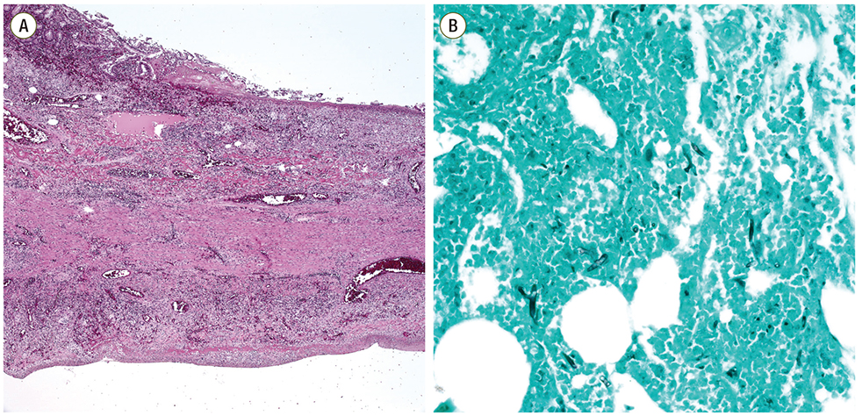
Figure 1. Microscopic findings of the resected small bowel. (A) Microscopic findings of the small bowel showed vasculitis and transmural infarction (H&E, ×40).
(Figure guide)
Images must be provided as TIFF files. JPEG is also acceptable when the original format is JPEG. Each figure must be good quality higher than 300 dpi resolution with good contrast and sharpness. The figures must be sized to 4 inches. If possible, submit the original file without any modification. Number figures as “Figure Arabic numeral” in order of citation (ex. Figure 1). If figure is divided into more than two, mark each figures with Arabic numeral and capital alphabet (Ex. Figure 1A, Figure 1B). An individual should not be recognizable in the photographs unless written consent of the subject has been obtained and is provided at the time of submission. Scales should be presented as a bar in the picture or as a magnification remark in the legend.
Except for especially complicated drawings that show large amounts of data, all figures are published at one page or one column width; when the figures are reduced to the size of a single column or of a single page width, the smallest parts of the figure must be legible.

Important Notes for Authors

Before applying:
- Be sure to revise the text linguistically and grammatically with a spelling and grammar checker.
- Check that all required sections are complete and comply with the journal's guidelines.
- Review the accuracy of references and citations and make sure that the approved documentation system is used.
- Make sure that tables and figures are of good quality, clear, and that they are correctly numbered and indicated in the text.
- Be sure to adhere to the word limit set for each section and for the article as a whole.

Application Requirements:
- Editable Word file (.docx) contains the full text, tables, and figures.
- PDF version of applied research submitted in LaTex format and confirmation of final format.
- Conflict of Interest Statement signed by all authors.
- The author's contribution statement outlines each author's role in the research.
- The letter of pledge of originality confirms that the research is original and has not been previously published.

Review Process:
- Initial Review: The article is checked by the editorial board for compliance with the prerequisites (5-7 business days).
- Scientific Review: The article is sent to specialized reviewers for in-depth evaluation (6-8 weeks).
- Final Review: After receiving the reviewers' feedback, the article is reviewed by the authors and the required adjustments are made (3-4 weeks).
- Publication: The article is published after final acceptance and any necessary formatting modifications are made.

Original Research Articles Template - Acapus Journal of Scientific Publishing - Version 1.0 Developed according to Scopus Q2/Q3 standards

